HW 4: Clustering Analysis

In this exercise, we will be using Weka to perform clustering on Superstore.arff dataset and then use Tableau to answer questions.

**Weka**

Import Superstore1.arff into Weka. Use the SimplekMeans algorithm to perform a clustering analysis. Make sure to keep **nine** clusters.

Make sure to include following set of parameters while clustering:

A)

1. Profit.Ratio
2. Category
3. Region
4. Segment

Provide Screen Shot of Clusters (Example)

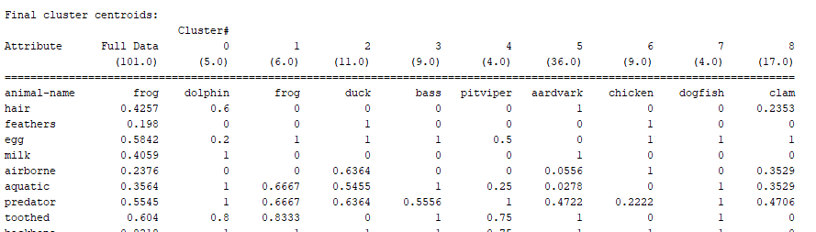

Now use Tableau to answer following Questions. To answer question:

1. Open Tableau Workbook
2. <https://public.tableau.com/profile/prof.stephen.wallace4806#!/vizhome/IST407-707/Customers?publish=yes>
3. Set filters to match Cluster
4. Answer questions (Hover over data point)

1. Person(s) with highest profit ratio?
2. Person with lowest profit ratio?
3. Which region had the highest profit ratio for all years? What was it?
4. Which region had the highest profit ratio in 2016? What was it?
5. Which region had the lowest profit ratio in 2016 in the technology and home office category? What was it?

B) Continuing to use the Superstore1.arff in Weka. Use the SimplekMeans algorithm to perform a clustering analysis. Make sure to keep **nine** clusters.

Create a new cluster - Make sure to include following set of parameters while clustering:

1. Sales
2. Category
3. Region
4. Segment

Provide Screen Shot of Clusters



1. Open Tableau Workbook

<https://public.tableau.com/profile/prof.stephen.wallace4806#!/vizhome/IST407-707/Customers?publish=yes>

1. Set filters to match Cluster
2. Answer questions (Hover over data point)
   1. Person(s) with highest profit ?
   2. Person(s) with lowest profit ?
   3. Which region had the highest profit for all years? What was it?
   4. Which region had the lowest profit in 2016 in the technology and home office category?